Customer Churn Prediction Project Images

churn_distribution.png

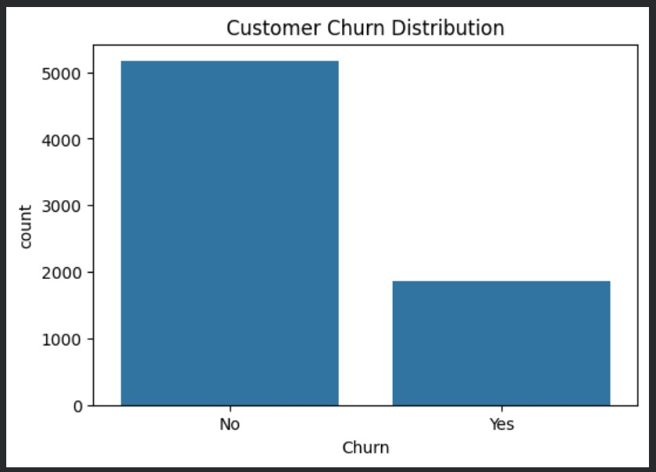

Contract vs Churn contract_vs_churn.png

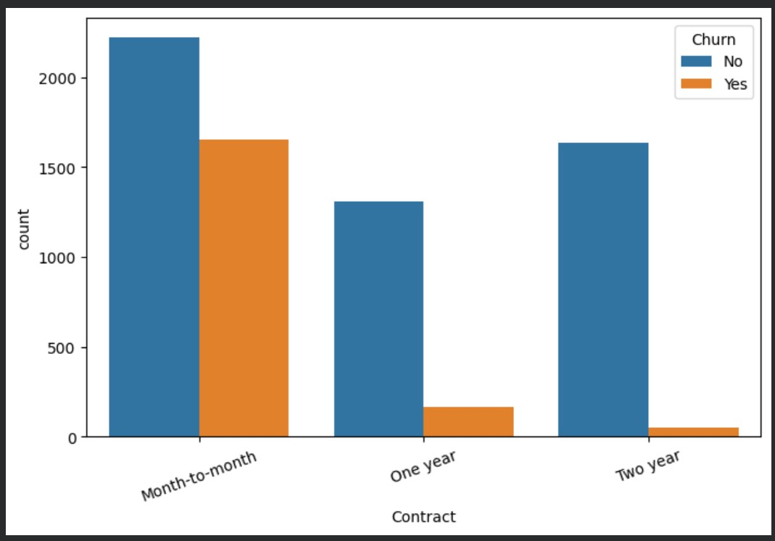

monthly_charges_vs_churn.png

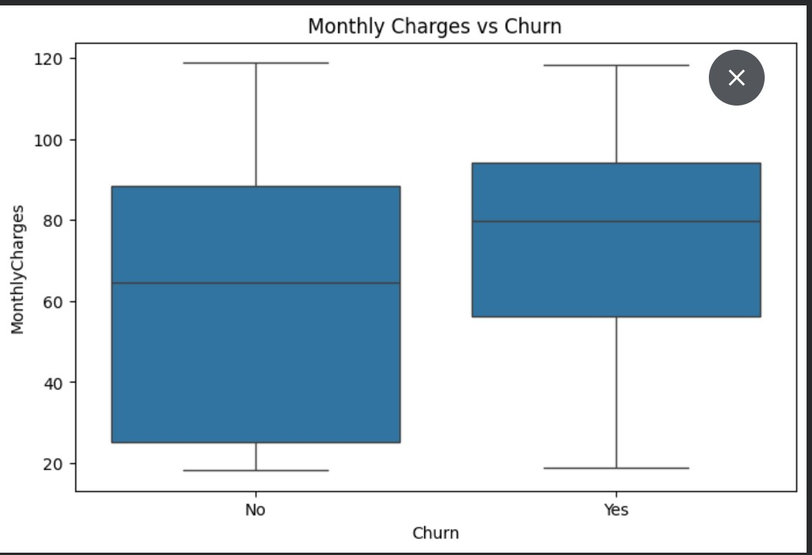

confusion_matrix.png

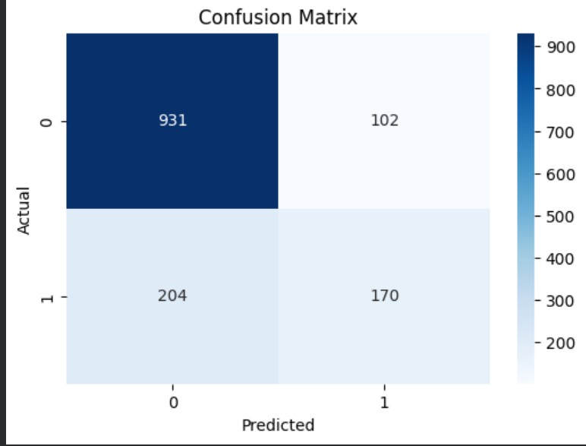
Feature Importance.png

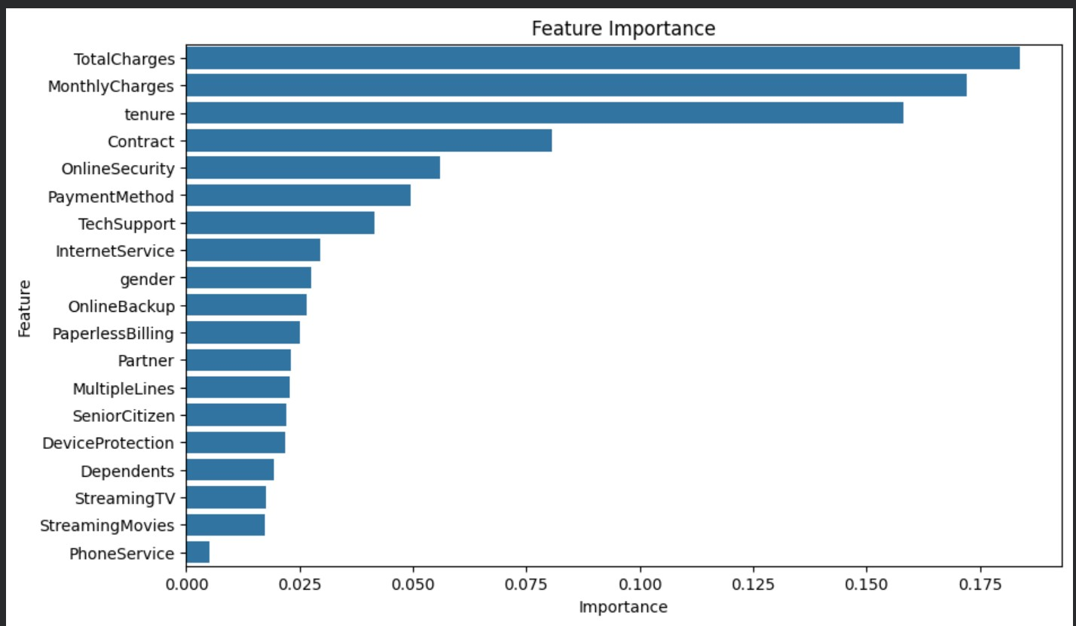
Dataset Head.png

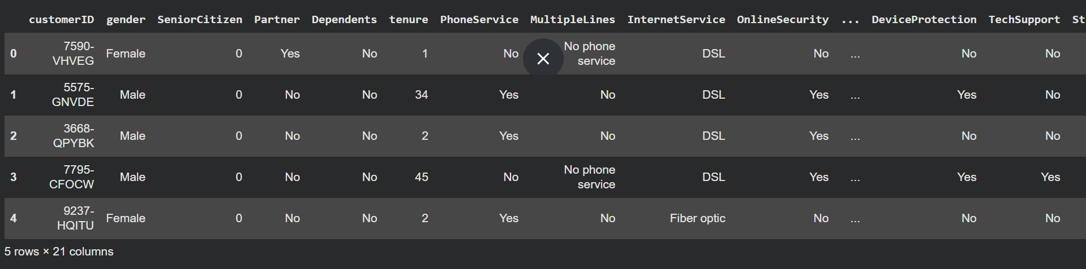

Data description.png

